Installer Modified Files

Game.cpp
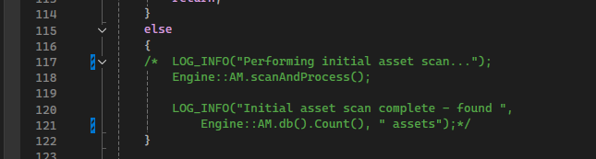
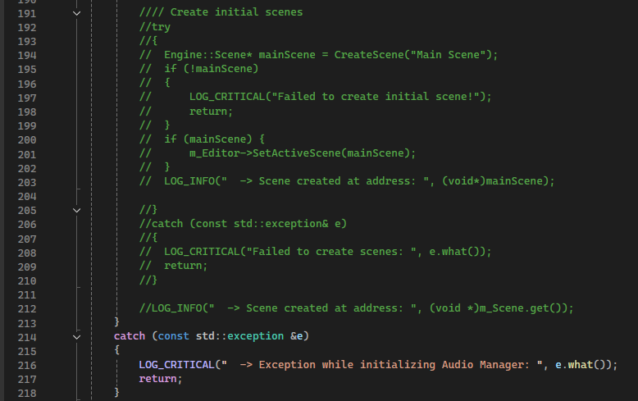
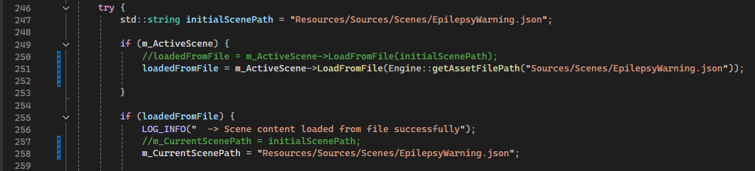
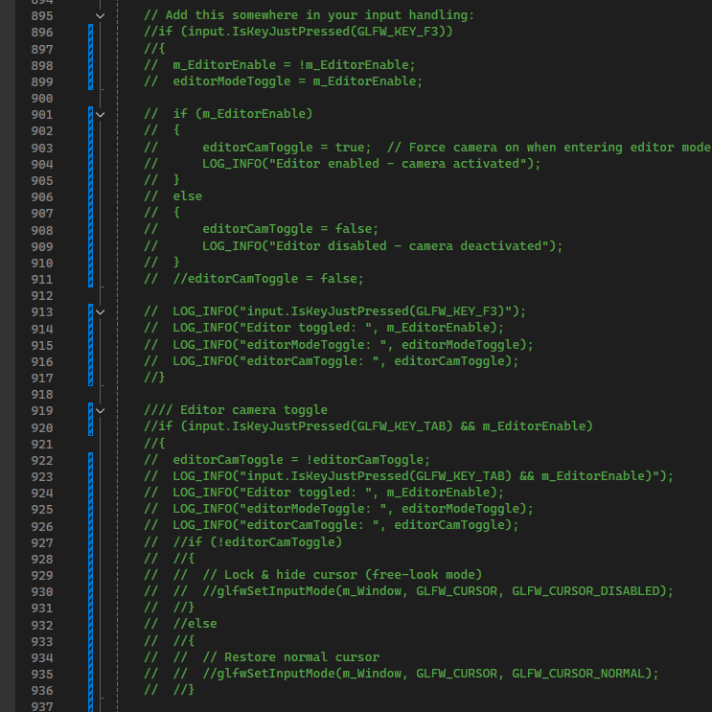
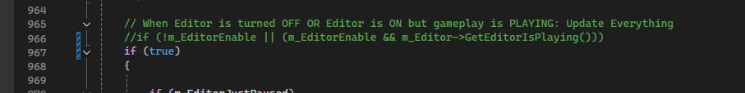
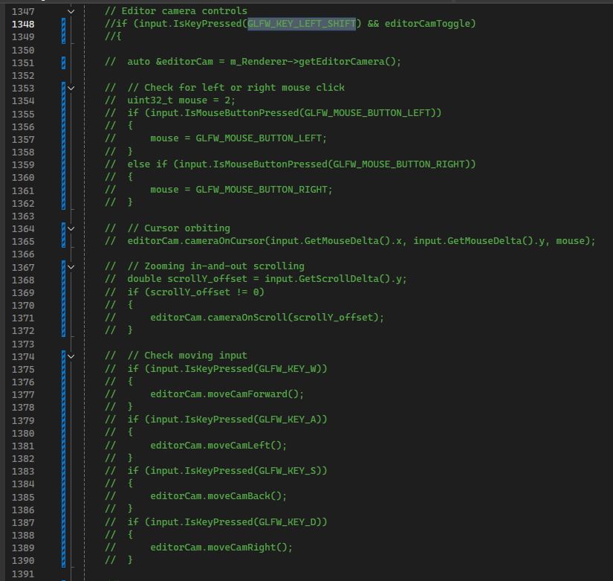
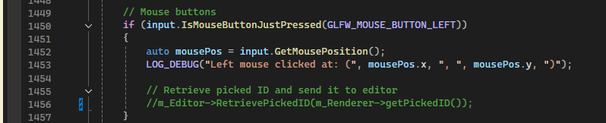

Editor.h
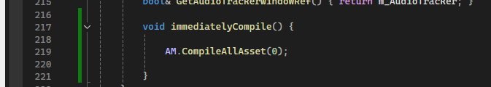

Editor.cpp
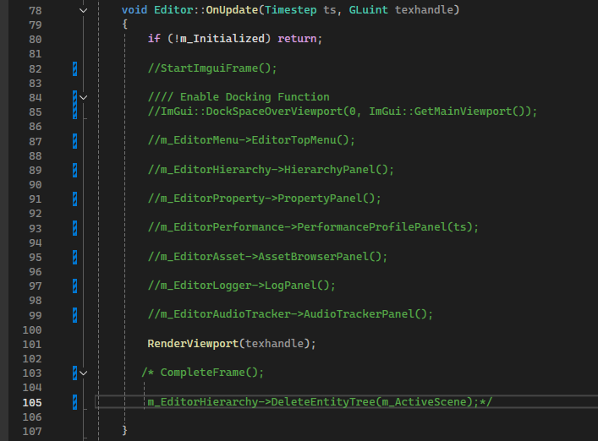

EditorViewportPanel.h
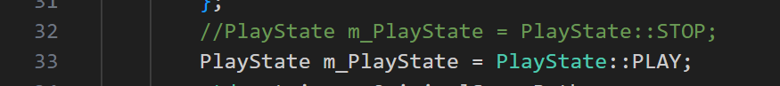

Renderer.h
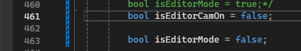

Renderer.cpp
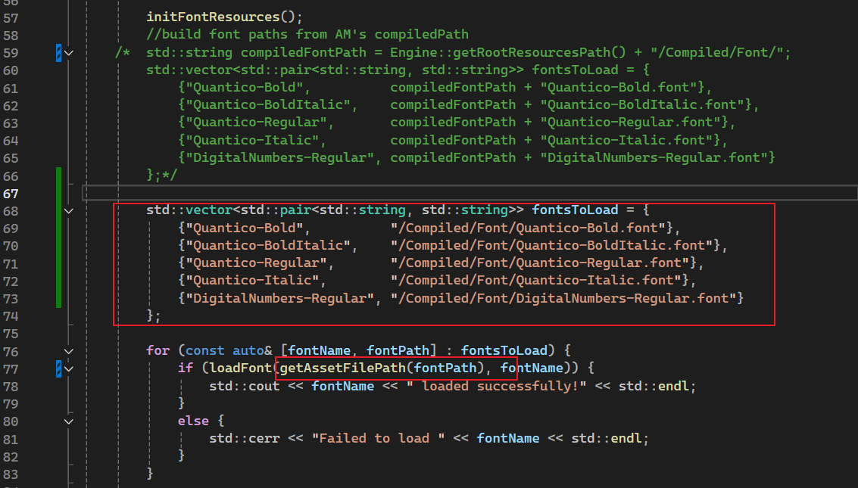
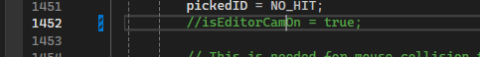 comment it

ResourceLoaders.cpp
In xresource::loader<Engine::ResourceGUID::material_type_guid_v>::Load()

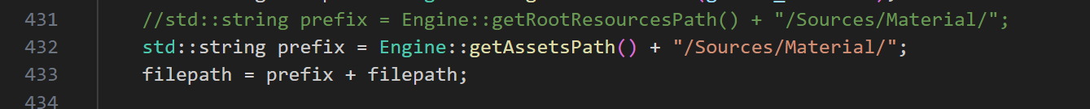

AssetScanner.cpp
in bool AssetScanner::LoadSnapshot(const std::string& file)

AssetManager.h
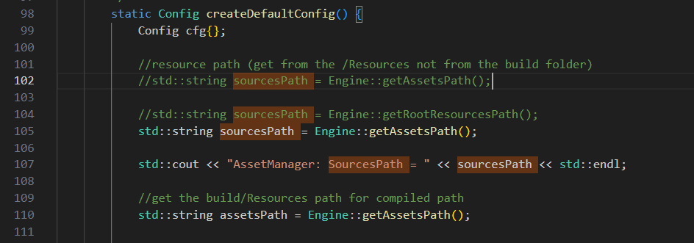

AssetDatabase.cpp
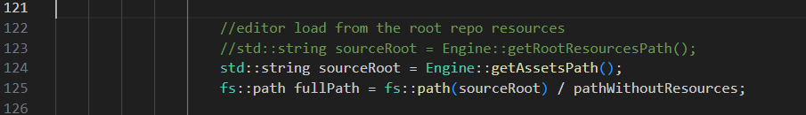

AssetCompiler/Main.cpp
